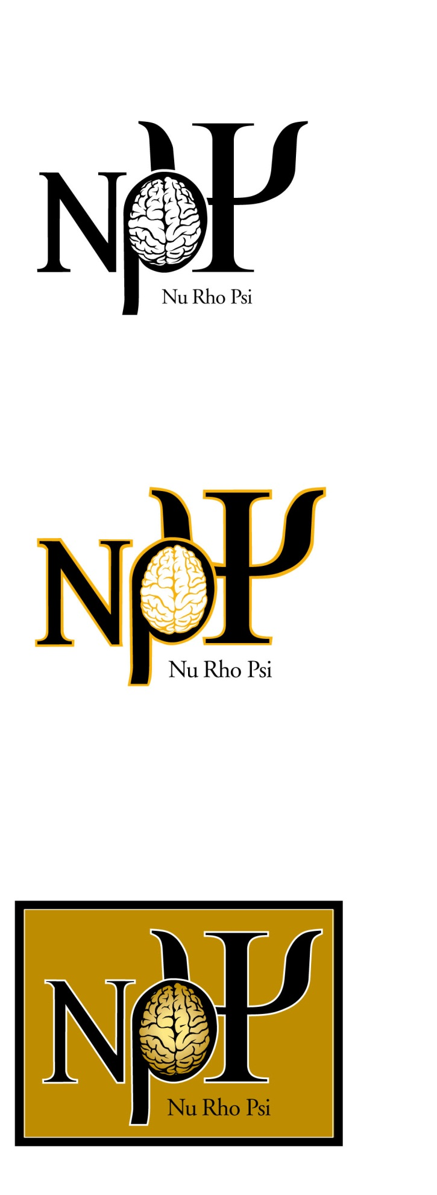

**National Membership Fee: $50.00** (made payable to NuRhoPsi, all funds go to national organization**)**

**Donation to local chapter*: _______**

**Total Submitted: _______**

*Donations will be used to establish a scholarship fund to offset the $40.00 undergraduate membership expense. Please write a separate check for donations, made payable to NuRhoPsi, UK Chapter

The Nu Rho Psi National Membership fee is **$50.00** for faculty members. This **one-time fee** pays for lifetime Nu Rho Psi membership, a certificate of membership, and a lapel pin. The Nu Rho Psi newsletter is on-line and may be accessed by members.

My signature verifies that I accept the Nu Rho Psi Constitution, which can be accessed at: <https://psychology.as.uky.edu/users/lsh223> under the Nu Rho Psi link.

Signed: ______________________________________________________Date: ______

**Name** _______________________________________________________________________ (*Maximum of 25 characters/spaces will fit on member certificate)*

**Mailing Address** ______________________________________________________________

*Street or P.O. Box*

____________________________________________ **E-mail** ____________

____________________________________________ **Phone** ____________

*City, State, Zip*

Membership Acceptance: Faculty

**N**u Rho Psi **THE NATIONAL HONOR SOCIETY IN NEUROSCIENCE**

National Office: Baldwin Wallace University, 275 Eastland Road, Berea, OH 44017-2088 Tel: 440.826.8526

**The following information is used only for internal Nu Rho Psi statistical purposes.**

Race/Ethnicity: ⁪ Asian/Pacific Islander ⁪ Black/African American ⁪ Hispanic/Latino Gender: ⁪ Female ⁪ Male

⁪ Multi Racial Background ⁪ Native American/ Alaskan American ⁪ White/Caucasian